Company  TOUR & ANDERSSON Tel +32 (0)10 68 89 64  Chaussée de Huy, 212 Fax +32 (0)10 68 09 83  B-1325 Chaumont-Gistoux, Belgium E-mail jc.carette@tahcollege.com |  | Date | Revised | Edition | Page
 |  | 2007-03-05 | 2007-03-09 | 3 | 1 (6)
Issuer | Approved | Title
Jean-Christophe Carette |  | Input and specifications for building up dynamically hydronic schemes in TA Select 3

Objective
To develop a C++ class allowing to build-up dynamically at run-time hydronic schemes needed in TA Select 3. The class will have to give as output an assembled hydronic scheme bitmap.

Class CEnBitmap is to be examined for determining if relevant as base class.

Hydronic schemes to be handled
The 6 following hydronic schemes are the currently targeted schemes for this function. More schemes with similar structure (and angle valves) will be added later on. In a later stage, actuators will have to "glued" on control valves in the hydronic schemes (see section Anticipated issues).
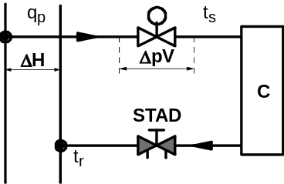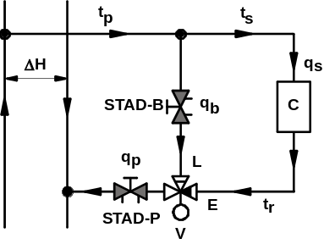
Two- way direct Three-way diverting

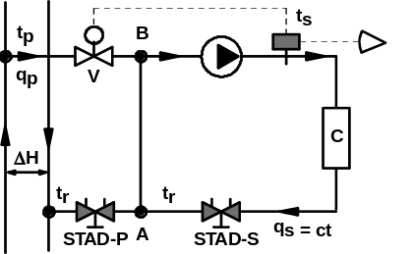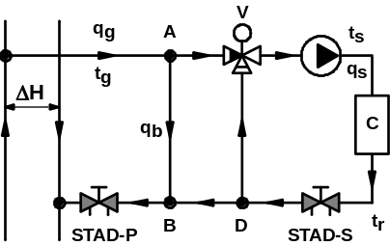
Two-way injection Three-way mixing with decoupling bypass

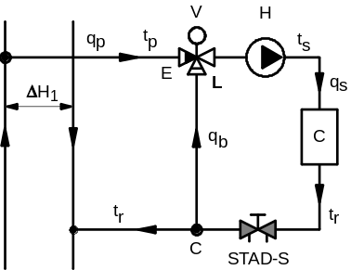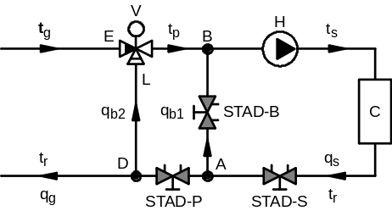
Three-way mixing Double mixing

Structure of pictures

Current structure of pictures
All hydronic schemes are currently made of 3 parts:

Upper part |  | 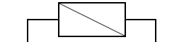 | or | 
Central part |  | 59 variants, for instance: |  | 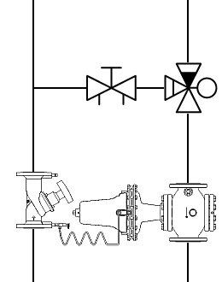
Bottom part |  |  | or | 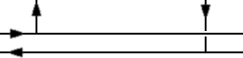

One idea for run-time build-up of hydronic schemes
The idea is to build up a background picture from the available bits for the upper, central and bottom parts; and then to stick on this background the actual drawings of the valves.

- For the central part of the background, any of the hydronic schemes can be built up based on one of the three following elementary pictures:



- Upper and connection parts are appended to the central part as currently made.
- Valve drawings are anchored on these pictures at anchoring points listed and characterized for each hydronic scheme.
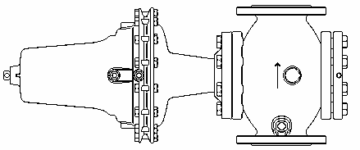

Valve drawings
- Always defined with normal flow direction at valve inlet pointing downward.
- All points are defined by their x,y pixel coordinates from the top left corner of the drawing.
- Points:
  - "In" point
  - "Bypass" point for 3-way valves
  - "Out" point
  - Capillary pipe anchoring point
- Valve orientation:
  - 2-way valves turned such that "In" to "Out" rotation on the opposite side of the handwheel is counter-clockwise.
  - 3-way or angle valves always given such that the "In-Bypass-Out" rotation of "In" port onto "Bypass" port and then "Out" port is counter-clockwise
In
In
In
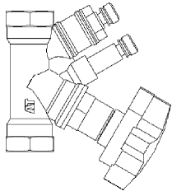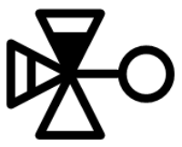
Out
Out
Out
Bypass

Anchoring points on hydronic scheme background
An anchoring point is defined for a certain valve type and for its function in the scheme. For instance, in the following scheme, there are two locations where a balancing valve should be anchored: the primary balancing valve (STAD-P) and the bypass balancing valve (STAD-B). And there is as well a location for a three-way control valve.

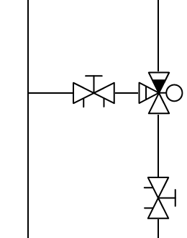
STAD-P
STAD-B

Parameters
- xy pixel coordinates with respect to the top left corner of the picture.
- Type: "Beg", "Mid", "End".
- Inlet flow direction: "N", "S", "E", "W".
- Function: "BVprim", "BVsec", "BVbypass", "CV", "DpC", "Pump".
- Structure: "2-way straight", "2-way angle", "3-way".
- Orientation: "Counter-clockwise", "Clockwise" (same convention as for valve drawings).

Anchoring point type, flow direction, structure and orientation determine the positioning of the valve drawing with respect to the anchoring point.
- Valve drawing is rotated to align itself with anchoring point inlet flow direction.
- Valve drawing is reflected with respect to the inlet flow axis if the orientation of the anchoring point is "Clockwise".
- Valve drawing position calculated from x,y coordinates and type of anchoring point:

Beg
Mid
End

- For 3-way valves, valve position adjusted such that x position of "In" point matches x coordinate of "Mid" anchoring point and y position of "Bypass" point matches y coordinate of anchoring point. Similar positioning performed for angle valves.

Anticipated issues
- Anchoring a valve drawing with a width that is larger than valve body length. Requires the implementation of pasting a valve drawing without its colour shaded background on a hydronic scheme.
Idea: store valve drawings with background shaded in a defined colour and implement a paste function that does not copy pixels made of this colour.

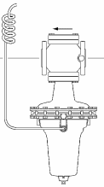

- Connecting one end of the capillary pipe from the Dp controller drawing to the other end of the capillary pipe from the measuring valve drawing. Requires the input of anchoring points for the capillary pipe and drawing an arc of parabola defined by the 2 capillary anchoring points and the mid-segment point shifted as 3rd point.

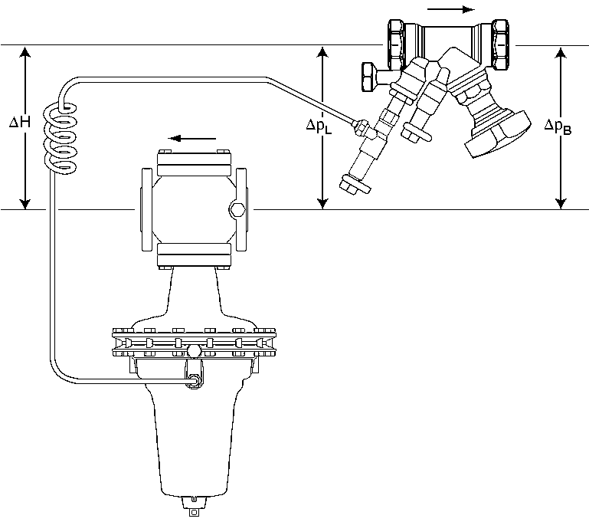 becomes 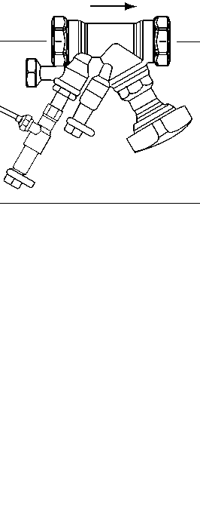

- Adding an actuator on a control valves. In general, actuators must be anchored on a control valve with a certain angle for Y-pattern valves. See below picture.

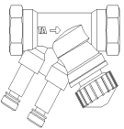

- Adding text for valve names to bitmaps will be needed.
Idea: Take into account the size of pasted valve drawing and try to place a textbox around it, detecting possible collision with drawn pixels. First attempted position as drawn below.

- Adding text and arrows to bitmaps will be needed. Will require additional anchoring points? Font size handling!

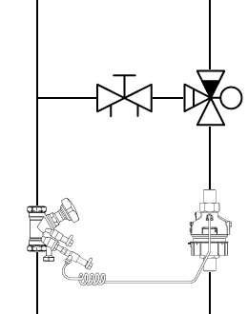
DpL = 45.6 kPa
Hmin = 63.4 kPa

